1.How are inline and block elements different from each other?

A- A Block level element places in a new line and takes the full width in both left and right available. Ex- Div is a block element

An Inline element doesnt take all available space and only takes as much space as it needs. It works in the same line instead of starting in a new line. Ex-span is an inline element.

2.Explain the difference between visibility:hidden and display:none

A- Visibility: hidden means the element is not visible but still takes space within the elements of the page. The tag is still present in the page, it’s just not seen at the present attribute.

Display: none, means the element is both not visible and won’t take any more space in the page.

Hence the difference between the 2 is that visibility: hidden means the element just wont been seen but still take space, but display:none means the element wont be seen nor will it take space.

3. Explain the clear and float properties.

A- Float property means to which direction the element will stick towards. For example, float: left means the element will be to the left side of the page, simmilarily float: right means the element will always be to the right side of the page. By default, it’s set to float:none so no float is set.

Clear property can control how the float of other elements will work with the element clear is applied on. Clear:left means no element will be allowed to float on the left side of this element, and vice versa for right. Clear:both means no element will be allowed to float neither to the left nor to the right of this element.

4. explain difference between absolute, relative,fixed and static.

In positioning the element, absolute means the element ‘child’ will follow the positioning with respect to the element ‘parent’ to that element. If no element found, the element ‘child’ treats the body as it’s parent and adjusts accordingly.

Relative means the element will be adjusted according to it’s positioning properties i.e. top, bottom, left and right properties.

Fixed means the element will remain at it’s position in a fixed manner, hence wont be affected by even scrolling of the page up or down.

Static means the element will be unaffected by any positioning provided in the properties. Hence, it will always follow the body and normal positioning

5. Write the HTML code to create a table in which there are 4 columns( ID , Employee Name, Designation, Department) and at least 6 rows. Also do some styling to it.

Table.html

6. Why do we use meta tags?

The meta tag provides page description to the internet, like the name of it’s author, it’s description etc. So, this is helpful in the Search Engine Optimization of the page.

7. Explain box model.

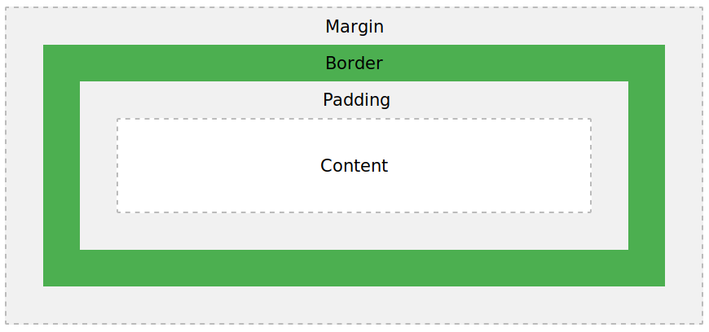

Here the content refers to the image/text or anything else that is displayed on the image.

Padding is transparent and is around the content in all directions.

After padding, a visible boundary around the content is the border

The margin is the area outside the border and is also invisible.

8. What are the different types of CSS Selectors?

Following are some major types of CSS selectors:

1. Tag selector: by simply writing the name of the selector, it can be referred in the CSS

Ex- a{}

2. ID selector is identified by putting a # symbol before the name of the tag

Ex- #idtag{}

3. Class selector is used to apply some rules to a set of elements, so all such elements will have same class name

Ex-.classtag{}

4. Descendent selector means combining multiple selectors to give specificiation where to apply the CSS

Ex- #idtag .classtag {}

9. Define Doctype.

The Doctype is used to tell the browser so that it can identify the html page and render it in standard mode, and use proper definitions from HTML and CSS. In the absence of the doctype, it might not be able to use many tools.

10. Explain 5 HTML5 semantic tags.

Major HTML5 semantic tags are:

1. The article tag is used to refer to the space used to display the article content in the webpage.
2. The sidebar tag is used to refer to the elements that will be set to the side, less important than the article. Ex- for sidebars
3. The header tag tells about the header of the web page.
4. The footer defines the footnote of the web page.
5. The nav tag is used to describe the navigation link elements in the page.

11. Create HTML for web-page.jpg (check resources, highest weightage for answers)

webpage.html

12. Create HTML for form.png (check resources, highest weightage for answers)

form.html